**Cover sheet for submission of work for assessment**

|  |
| --- |
| UNIT DETAILS |

|  |  |  |  |  |  |  |
| --- | --- | --- | --- | --- | --- | --- |
| Unit name | Network Security | | | Class day/time |  | Office use only |
| Unit code | INT3307_20 | Assign no. | 1 | Due date | 10/1/2022 |
| Name of lecture/teacher | | Dr. Nguyen Dai Tho | | | |
| Tutor/marker’s name | |  | | | |

|  |
| --- |
| STUDENT(S) |

|  |  |  |  |  |  |
| --- | --- | --- | --- | --- | --- |
| Family Name(S) | | Given Name(S) | | Student ID Number(s) | |
| Nguyen Trung | Hieu | | 19021271 | |

|  |
| --- |
| DECLARATION AND STATEMENT OF AUTHORSHIP |

1. I have not impersonated, or allowed myself to be impersonated by any person for the purposes of this assessment.

2. This assessment is my original work and no part of it has been copied from any other source except where due acknowledgement is made.

3. No part of this assessment has been written for me by any other person except where such collaboration has been authorized by the lecturer/teacher concerned.

4. I have not previously submitted this work for this or any other course/unit.

5. I give permission for my assessment response to be reproduced, communicated, compared and archived for plagiarism detection, benchmarking or educational purposes.

I understand that:

6. Plagiarism is the presentation of the work, idea or creation of another person as though it is your own. It is a form of cheating and is a very serious academic offence that may lead to exclusion from the University. Plagiarized material can be drawn from, and presented in, written, graphic and visual form, including electronic data and oral presentations. Plagiarism occurs when the origin of the material used is not appropriately cited.

**Student signature/s**

I declare that I have read and understood the declaration and statement of authorship.

*Nguyen Trung Hieu*

**ABSTRACT**.  
Nowadays, most of us have heard of at least one cryptocurrency's name, since these blockchain-based virtual currency usage has been in circulation for the last twelve years and has recently been highly popular. As of now, the crypto market cap is currently sitting at $2.6 trillion. So, while the cryptography market appears to be lucrative, it has attracted a lot of malicious users who are attempting to hack and steal these. As a result, the majority of those who participate in the market are concerned about the security of these cryptocurrencies. This research will delve into how the use of blockchain technology affects cryptocurrency security and a number of protection mechanisms against attacks.

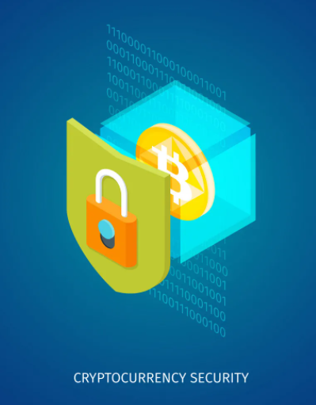

ASSIGNMENT 1

SECURTY IN BLOCKCHAIN-BASED CRYPTOCURRENCY

Name: Nguyen Trung Hieu

Birthdate: 16/04/2001

Student ID: 19021271

Email: 19021271@vnu.edu.vn

University of Engineering and Technology

Summited in 10/01/2022

Due date: 10/01/2022

# Table of Contents

Table of Contents 1

I. Introduction: What is cryptocurrency and blockchain 2

a. Some terminology 2

b. What is cryptocurrencies and how it started 2

II. Current state of art 3

a. Some more terminology used in this section 3

b. Literature review 4

1. Bitcoin: A Peer-to-Peer Electronic Cash System (Length: 9) 4

2. Security of Cryptocurrencies in blockchain technology: State-of-art, challenges and future prospects (Length: 35) 4

3. BlockSecIoTNet: Blockchain-based decentralized security architecture for IoT network (Length: 11) 5

4. Analysis of Security in Blockchain: Case Study in 51%-Attack Detecting (Length: 10) 6

5. Random Mining Group Selection to Prevent 51% Attacks on Bitcoin (Length: 2) 7

6. A new key protocol design for cryptocurrency wallet (Length: 6) 7

c. Analysis of the paper 7

III. Conclusion 8

IV. References 9

# I. Introduction: What is cryptocurrency and blockchain

## a. Some terminology

#### Decentralized networks

A decentralized network architecture distributes workloads among several machines, instead of relying on a single central server [W5]

#### Public ledger

A record-keeping system that keeps track of participants' identities in a secure and (semi-)anonymous form, as well as their respective bitcoin balances and a log of all real network transactions[W10].

#### Peer-to-peer

Two users interact directly without the need of a third party or intermediary.

#### Cryptocurrency wallet

A wallet where one can keep their cryptocurrency.

#### Mining

A process that using CPUs to solve various mathematical puzzles that basically the processing of transactions and an amount of cryptocurrency will be given to the miner wallet as compensation for processing the transaction.

#### Double-spend

It simply a certain amount of asset can be spent twice in a digital currency system because of faulty duplication.

## b. What is cryptocurrencies and how it started

Cryptocurrencies are a digital currency that utilize various cryptographic methods and algorithms like hashing function and public-private key pairs to encrypt transactions between users, hence the “crypto” part of the name. The mean of acquisition is either buying them directly from various cryptocurrency trading platform or *mining* them.

When talking about them, many people think that Bitcoin or BTC is the first one enter to exist, but actually it only the first blockchain based cryptocurrency. The pioneer of digital payment is DigiCash founded by David Chaum in 1989 and the concept of it made by him actually date back several years earlier while the first concept of blockchain worked on by Stuart Haber and Scot Stornetta started in 1991. DigiCash declare bankruptcy in 1998 but many of its formula and encryption tools helped the development of modern digital currency.

In 2008, a 9 papers long whitepaper about Bitcoin made by Satoshi Nakamoto, whose identity today is still actually unknown as that’s just the name got put in the paper. In short, the document proposed a peer-to peer digital transaction network system that doesn’t need any third-parties, the record of all transactions can’t be corrupted or hard to be reversed, preventing counterfeit or *double-spend*, based on blockchain model [W4]. The success of bitcoin has launched several other cryptocurrencies into existence, most of them share the same characteristic that bitcoin has: a *decentralized* *network* with transaction recorded with blockchain technology, a *public ledger*.

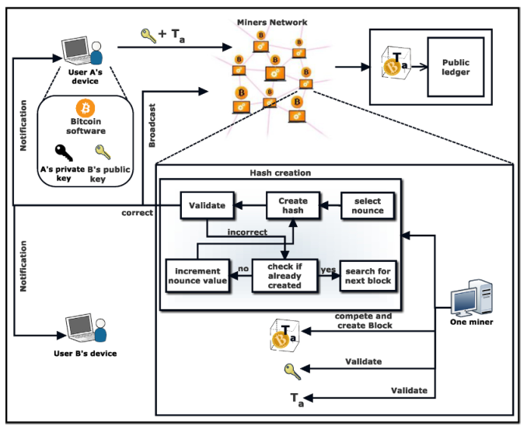

Life cycle of transaction in a bitcoin network [P2]

As of now there is estimated to be 300 million cryptocurrency users worldwide, there are 18,000 businesses and brands that accept cryptocurrency as payments. Bitcoin were made available to the public in the 2009 and currently still the world most widely exchanged cryptocurrency. As of now it worth sky-high 46,412.50 USD, followed by Ethereum and Binace coin that while valued much less compared to bitcoin: 3,809.00 USD and 512.7 USD, still very prized.

That combined with the significant amount of effort required to modify transactions record however has make it attractive to criminal. The victim simply cannot ask for a redo of transactions like traditional bank if they got the wallet stolen and they most certainly can’t do that themselves. The thieves can remains anonymous even if all transactions are public, the wallet address simply contain no information, make it impossible to trace the attacker. The number of fraudulent transactions or hacking the system has raised even more as it got more popular. Nowadays attacks with damage up to hundreds of million dollar happen quite common, they can also happen in smaller scale of course but in total they has accumulated $1.93 billion. The attack can be committed by a lone wolf or an entire cybercrime organization behind it. It is speculated that nearly $1 billion has been stolen from exchanges by two groups of cybercriminal that still active as of today [W7].

As a result, substantial research and analyses into the present security measures of blockchain-based crypto currency have been conducted. I'm writing this essay because I'm fascinated by cryptocurrency and want to learn more about it. The following literature analysis will concentrate on cryptocurrency network attack.

# II. Current state of art

## a. Some more terminology used in this section

#### Byzantine Fault

A situation where the framework may collapse if the members cannot agree on a network approach. The Fault assumes that certain members are corrupt, ineffective, or undemocratic, emphasizing that even a single point of failure might jeopardize the entire strategy.

#### Public key

The address of someone’s cryptocurrency wallet.

#### Private Key

The code that permits one to get immediate access to their cryptocurrency wallet, similar to a password.

#### Hashpower

Hash power, or hash rate, are interchangeable terms used to describe the combined computational power of a specific cryptocurrency network or the power of an individual mining rig on that network [W9].

#### 51% Attack

A situation where more over half of the network's mining hash rate is controlled by a small handful of miners. They would be able to block fresh transactions from receiving confirmations, effectively halting all transactions between merchants and customers. As a result, their transactions will be linked to the longest chain of transactions [P4]. It related to double-spending attack.

## b. Literature review

### 1. Bitcoin: A Peer-to-Peer Electronic Cash System (Length: 9)

In this paper [1] made by Satoshi Nakamoto, who we don’t know whether they is an individual or a group as they refer to themselves as we, they propose a system that allow transactions of currency to be third-party free as back in the day most online payment system still have to go through a trusted third party like bank, using decentralized network and peer-to-peer transactions that is immutable through cryptography. When someone transfers a certain amount of bitcoin to another user, the network verifies various information from previous blocks to create future block to ensure the amount get exchanged is correct. The transfer is irreversible. Transaction then stored in a Merkle tree data structure with auto-pruning of branches to efficiency store data.

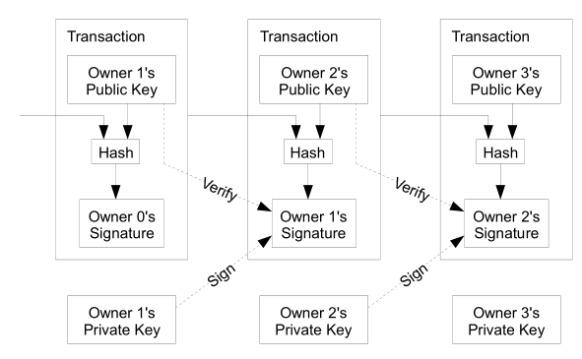 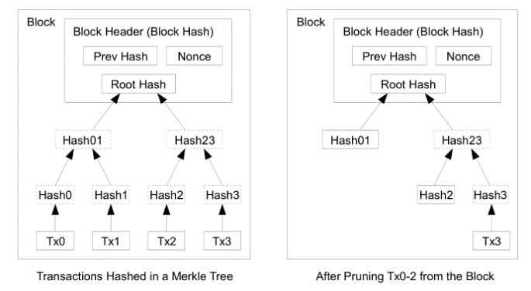

Transaction Structure

To prevent nefarious transactions from being put into the network, he propose a proof-of-work system. It use SHA-256 to create a hash value to attaches of each transaction to a puzzle. The puzzle must be solved correctly by the sender’s system to execute the transaction. The block then will be put in the longest nodes. The transaction history will be limited to the network of blocks that increasing in length as more transaction get made and nearly impossible to modify. If attack still wish to do so they would need to have at least 51% of computational power of the network as they have to redo every future nodes and catch up with the longest nodes of transaction. In a nut shell attacker have to alter an entire chain to modify a single transactions.

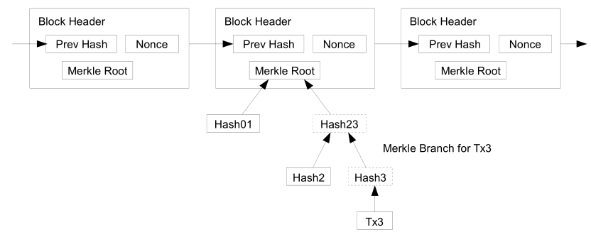

A proof-of-work chain

There are incentive to participate in a honest way as the miner get certain amount of bitcoin back as an award for processing the transactions of other users. And if attackers has enough hash power to overpower the network they would have to choose whether if they got more profit from just play by the rule and get coins or by making defrauded transactions to steal coins. The former ought to be more profitable though as the chance to successfully perform a 51%-Attack is very slim.

### 2. Security of Cryptocurrencies in blockchain technology: State-of-art, challenges and future prospects (Length: 35)

In this document [2] by the team of researcher, Arunima Ghosh, Shashank Gupta, Amit Dua, Neeraj Kumar, they analyzed the overall structure of blockchain as they listed several features of it. While blockchain has a decentralized nature, it isn’t prone to single point of failure unlike public key infrastructure (PKI) so it is Byzantine fault tolerant. It also has a good persistency as authentication of transaction is very fast with good accuracy. Users has good auditability as every records of every user is immutable can be easily traced while user still retain semi anonymity as the wallet of each user doesn’t contain any identifiable information. But there are some issue of it as while there still isn’t an efficient way of hacking blockchain network as it is very robust, people still reported damaged from attack ranging from service interruptions to thievery of confidential information and valued assets. However the number of case is relatively low compare to it scale and they concluded that with decentralization, persistency, privacy and auditability features, blockchain can be applied to enhance more conventional IT field.

Smart contracts have been employed in a variety of new Blockchain types, with Ethereum being the first to do so. They essentially are programs that run when certain criteria are satisfied and are maintained on a blockchain. They are executed when miners mining blocks.

Nevertheless, there are still a number of vulnerabilities of blockchain, such as 51%-Attack, Data malleability or various traditional security breaching categories like DDos, private account hacking… To combat the attacks, the authors mentioned a number of security enhancement techniques that have lately been used by the blockchain network of newer cryptocurrency.

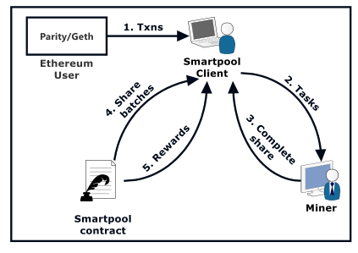First is SmartPool, used by Ethereum, makes use of a data structure called *augmented Merkle tree* that has the ability to avoid the adversary from submitting the shares in various batches. Moreover, the authentication methodology of SmartPool assures that legitimate miners will get anticipated incentives even if dishonest miners are present in the pool.

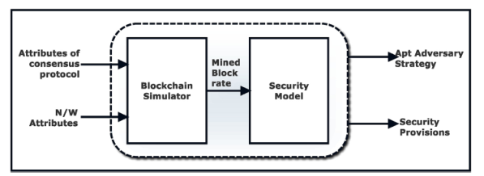

Second is *quantitative framework* with focus on the proof of work system. It run a stimulator and the data from the stimulation will be analyzed to assess the blockchain’s performance.

Third Oyente

Fourth Hawk

Finally Town Crier

The list doesn’t stop here though, many more techniques are being developed and we will see them in the future

### 3. BlockSecIoTNet: Blockchain-based decentralized security architecture for IoT network (Length: 11)

Shailendra Rathorea, Byung Wook Kwon, Jong Hyuk Park

This paper discuss about how blockchain can improve existing flaw of decentralized network architecture. While it isn’t about cryptocurrency it can give us some insight in the blockchain. They proposed a decentralized security architecture for the IoT ecosystem that detects and mitigates security attacks. Three new contributions to IoT security have been made by the proposed architecture. First, the proposed architecture employs software defined to continuously monitor and analyze traffic data across the entire IoT ecosystem, addressing the issue of data unavailability in security detection and ensuring the best possible security defense. Second, the architecture makes use of Blockchain technology, which allows for decentralized attack detection and thus avoids the single point of failure problem that centralized and distributed architectures have.

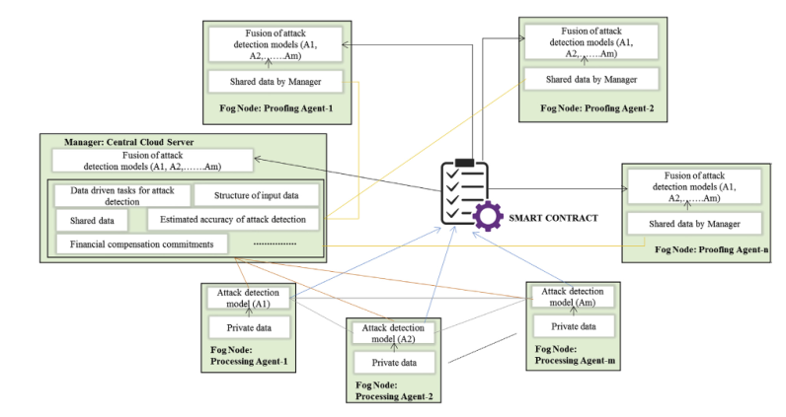

Finally, the architecture employs a layered structure, in which attacks are detected at the fog node and then mitigated at the edge node, reducing the time it takes to detect and mitigate attacks. According to their findings, the proposed decentralized security architecture outperforms centralized and distributed security architectures and takes less time to mitigate attacks in the IoT ecosystem. Their findings also suggest that the architecture could be used with the IoT ecosystem as a security detection component that monitors and analyzes the entire IoT ecosystem's traffic data to detect and mitigate potential attacks.

So if the blockchain network is monitored, we can create a system that send alert message of the attack to all hosts quickly, therefore mitigate as many loss as possible.

### 4. Analysis of Security in Blockchain: Case Study in 51%-Attack Detecting (Length: 10)

Congcong Ye, Guoqiang Li, Hongming Cai, Yonggen Gu, Akira Fukuda.

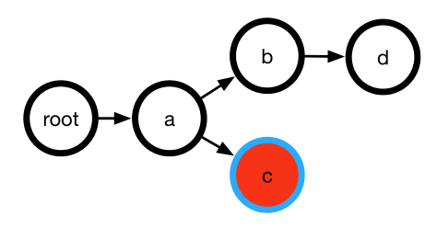In the paper they propose a tree-structure method to simulate the blockchain process and analyze the relationship between attacking number and state number in order to assess the security of each state in this paper. They have used the 51% -Attack strategy to simulate attacker behavior and determine the state number and attacking number change trends. Afterward when the data can be extracted, the security of each state in the blockchain can be assessed.

**Algorithm 1** Obtain all state of simulation process about blockchain

**Input**: The attacking power P

**Output**: All state of blockchain S

1: Initialize a blockchain with a honest node R

2: Create a new block based on network’s attacking power;

3: **repeat**

4: create new block based on power of attacking P;

5: **if** new block is honest one **then**

6: Algorithm 2;

7: **else**

8: Choose the longest chain which will make attacking block safer.

9: **end if**

10: Reconstruct a new tree by connect new block to the chosen node;

11: **if** the state of new tree is different from the state in S **then**

12: Join the new state into S

13: **end if**

14: **if** the new tree reaches security state or attacking state **then**

15: Initialize a blockchain with a honest node

16: **end if**

17: **until** the state number of blockchain S converges

18: **return** all state of simulation process blockchain S

**Algorithm 2** How to choose one node the new honest node will connect

**Input**: The root of the blockchain P

**Output**: One node that new honest node will connect S

1: Calculate the depth of a tree L

2: **for** every layer i=0 **to** n **do**

3: **for** every node j=0 **to** m **do**

4: Add weight of every node

5: **end for**

6: **end for**

7: Choose one node based on the probability P that was calculated above

8: **return** node S

They believe this can create a more generic tool to detect the condition of blockchain and alert users that they may have to wait a long time to accept transactions, thereby improving blockchain security.

### 5. Random Mining Group Selection to Prevent 51% Attacks on Bitcoin (Length: 2)

As mentioned, Bitcoin is known for resolving double-spending problems, the longest chain of block is selected to it. However, if there is a group of nodes which hash power is greater than half of the total hash power, they can perform a 51% attack. So in this document [P5] by Jaewon Bae and Hyuk Lim propose a solution to prevent said attack of the Bitcoin network called Random Mining Group Selection.

The miner will be divided into multiple group, not all miners are always involved in the mining process, and only miners belonging to a certain group are permitted to mine the next block. The node’s mining group will be determined by a hash function. The network can easily verify whether the node is in it correct mining group by comparing hash value of the previous block in the block header.

So with the proposed solution attacker can’t easily extend their chain of node and thus reduce the chance of a 51% attack.

### 6. A new key protocol design for cryptocurrency wallet (Length: 6)

The bulk of cryptocurrency hacking incidents occur when a cryptocurrency wallet's information is stolen. When connecting to a transaction network, the cryptocurrency wallet is vulnerable to key theft because it is utilized for key storage. While the cash is not stored in the cryptocurrency wallet, the key that grants access to the account is. Soonhwa Sung's study [P6] proposes a key protocol that uses a session key agreement rather than key storage in a wallet to prevent wallet information theft.

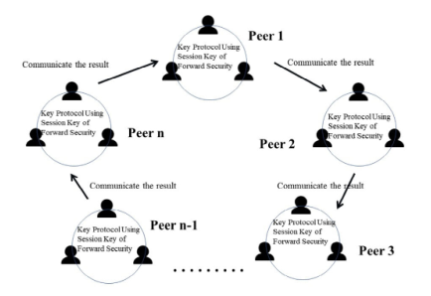 This protocol is processed by the session key authentication, which uses key sessions, and the cluster key in a peer. A peer is made up of several parties, each of which has at least three members. For valid users, each peer must proceed with the key protocol using a session key depending on the forward security. Then the key uses the Federated Byzantine Agreement (FBA), requiring nodes to be known and verified before being allowed to perform transactions, based on blockchain technology to perform multiparty calculations. The keys also are used to prevent collusion between miners and data recipients on the blockchain.

## c. Analysis on security

The average CPU's processing power has increased as technology has progressed. People have even deduced which type and brand of CPU is best for cryptocurrency mining. Nothing prevents an attacker from obtaining the same CPU. And, as history has shown, someone will always find a way to defeat a complex security algorithm when given the opportunity. So cryptocurrency was not created with the intention of minimize the number of attack as much as possible, shown in the whitepaper[P1] as Satoshi Nakamoto calculated in theory the rate in which an attack can catch up with the honest chain in a proof-of-work system is by a Binominal Random Walk

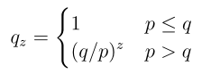 With *p* represent the probability that the honest node find the new block first, *q* represent the probability that the attackers find them faster than the honest node so p + q = 1. *qz*is the probability that the attacker catch up the honest node chain when *z* block behind. (1)

So if p > q, as the number of blocks the attacker has to catch up with grows, the probability decreases exponentially. With the odds stacked against him his chances of catching up quickly dwindle. Otherwise the attacker is guaranteed to success.

__The possibility that the attacker will be able to catch up now is

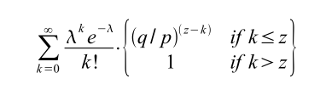with λ = $z\frac{q}{p}$ as the expected value of the Poisson distribution.

In statistic, a Poisson distribution is a probability distribution that depicts the number of times an event is expected to occur over a given time period. To put it another way, it's a count distribution. Poisson distributions are frequently used to comprehend independent events that occur at a steady rate during a particular time frame. [W11] So the distribution fits here.

With some arrangement to prevent summing the distribution's infinite tail it became

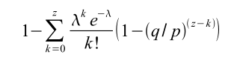

After the above equation converted into C

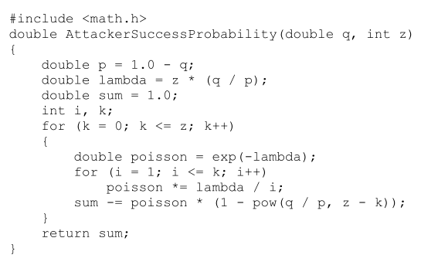

They ran the code with different probability of attacker faster than the network and the number of block be hinds. This is the results:

|  |  |
| --- | --- |
| when q = 0.1 | |
| z | P |
| 0 | 1.0000000 |
| 1 | 0.2045873 |
| 2 | 0.0509779 |
| 3 | 0.0131722 |
| 4 | 0.0034552 |
| 5 | 0.0009137 |
| 6 | 0.0002428 |

|  |  |
| --- | --- |
| When q = 0.3 | |
| Z | P |
| 0 | 1.0000000 |
| 5 | 0.1773523 |
| 10 | 0.0416605 |
| 15 | 0.0101008 |
| 20 | 0.0024804 |
| 25 | 0.0006132 |
| 30 | 0.0001522 |

So with the chances are stacked against the attacker, it provide an incentive to act honestly since it will waste time and electricity of attacker.

In [P4]

In this document they have stimulated a 51%-Attacks to evaluate the security of blockchain by introducing state including honest state and attack state.

Attack state represent attackers as they try to create illusory transactions and know whether the other block is also an illusory one so they can choose to connect to the most suitable one decided by the following equation:

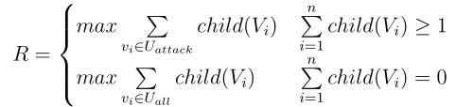With *R* represents the most suitable block, *Vi* represents block *i* in attacking collection or in the whole blockchain and the *child()* function return the number of child nodes *Vi* has.

So if no attacking nodes are present on the blockchain, the attackers will choose the longest chain. Otherwise, attackers will pick the chain in which the attacking node connects to the most nodes.

Honest miner on the other hand don’t know whether a node is fraud or not so the honest node will default the transactions in the longest chain is correct as usual.

Various studies about bitcoin show that if there are more than 6 blocks connect to a block, the block can’t be changed in a real condition. So if 6 of them are connected to an illusory one the attack is success.

To furthermore secure the blockchain network, in [P5], the authors said that in (1) q is the ratio of the hash power of the attacker to the total hash power of N peers in the network (H). Assume that *m* groups have the same average number of users and the same average hash power, when random group selection is used q will be express as follow:

q~ = $\frac{1}{m}$. $\frac{h}{h+(\frac{N}{m}-1)(\frac{H-h}{N-1})}$

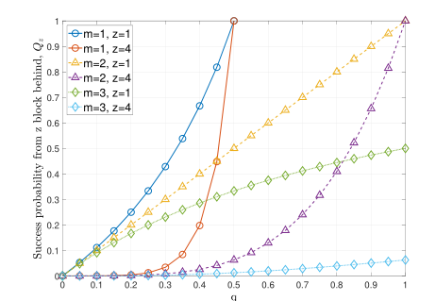So with m ≥ 2, q~ cannot be greater than 50% as 1/m will less than or equal ½ and $\frac{h}{h+(\frac{N}{m}-1)(\frac{H-h}{N-1})}$ is always less than or equal to 1.

The graph from [P5] shows the probability of a successful double-spending attack. The graph was plotted into six group with z = 1 or 3 and m from 1 to 3. So when m equal 1 it is the case of a network not using the random selection group system.

We can see that the attack is guaranteed to success when q slightly cross 0.5 or 50% of network hashpower no matter how many z behind. However with just m = 2 we can see that the chance for a success attack greatly reduced even if they are only 1 block behind. To guarantee that the attack will be success attacker would need to have 100% control of the network, which obviously not happen because why would they have the need to attack their own network.

So the rate of attack

In [P2]

Against 51%-Attack they mentioned some defense

Several type of attack has been listed

Double-spending

Finney Attack

Brute force attack

Vector 76 attack

Goldfinger, unlike 51%

Selfish mining

Block withholding

FAW attack

# III. Conclusion

So in this paper we can conclude that

# IV. References

**Version control and archival site**

[taiyounari/NetworkSecurityEssay: Network security course project (github.com)](https://github.com/taiyounari/NetworkSecurityEssay)

**Used material (Click to redirect to the link)**

*Website articles and blogs*

[W1] [Global Cryptocurrency Ownership Data 2021 - TripleA (triple-a.io)](https://triple-a.io/crypto-ownership/)

[W2] [Cybersecurity in Cryptocurrency: Risks to Be Considered - DATAVERSITY](https://www.dataversity.net/cybersecurity-in-cryptocurrency-risks-to-be-considered/)

[W3] [Cryptocurrency Definition](https://www.investopedia.com/terms/c/cryptocurrency.asp)

[W4] [Bitcoin Definition](https://www.investopedia.com/terms/b/bitcoin.asp)

[W5] [The Difference Between Centralized and Decentralized Networks | N-able](https://www.n-able.com/blog/centralized-vs-decentralized-network#:~:text=What%20is%20a%20decentralized%20network,on%20a%20single%20central%20server.)

[W6] [51% Attack Definition](https://www.investopedia.com/terms/1/51-attack.asp)

[W7] [Once hailed as unhackable, blockchains are now getting hacked](https://www.technologyreview.com/2019/02/19/239592/once-hailed-as-unhackable-blockchains-are-now-getting-hacked/)

[W8] [Crypto Terms You Should Know If You Want to Invest](https://time.com/nextadvisor/investing/cryptocurrency/crypto-terms-you-should-know-before-investing/)

[W9] [Hash Power / Hash Rate](https://coinmarketcap.com/alexandria/glossary/hash-power-hash-rate#:~:text=Hash%20power%2C%20or%20hash%20rate,mining%20rig%20on%20that%20network.&text=The%20hash%20rate%20of%20a,it%20can%20calculate%20per%20second.)

[W10] [Cryptocurrency Public Ledger Defined](https://www.investopedia.com/tech/what-cryptocurrency-public-ledger/#:~:text=The%20public%20ledger%20is%20used,transactions%20executed%20between%20network%20participants.)

[W11] [Poisson Distribution Definition](https://www.investopedia.com/terms/p/poisson-distribution.asp)

*Papers and journals*

[P1] [Bitcoin: A Peer-to-Peer Electronic Cash System](https://bitcoin.org/bitcoin.pdf) Satoshi Nakamoto

[P2] [Security of Cryptocurrencies in blockchain technology: State-of-art, challenges and future prospects](https://www.sciencedirect.com/science/article/abs/pii/S1084804520301090) Arunima Ghosh, Shashank Gupta , Amit Dua , Neeraj Kumar

[P3] [BlockSecIoTNet: Blockchain-based decentralized security architecture for IoT network](https://www.sciencedirect.com/science/article/abs/pii/S1084804519302243) Shailendra Rathore, Byung Wook Kwon, Jong Hyuk Park

[P4] [Analysis of Security in Blockchain: Case Study in 51%-Attack Detecting](https://ieeexplore.ieee.org/document/8563187) Congcong Ye, Guoqiang Li, Hongming Cai, Yonggen Gu, Akira Fukuda

[P5] [Random Mining Group Selection to Prevent 51% Attacks on Bitcoin](https://ieeexplore.ieee.org/document/8416225) Jaewon Bae, Hyuk Lim

[P6] [A new key protocol design for cryptocurrency wallet](https://www.sciencedirect.com/science/article/pii/S2405959521000904) Soonhwa Sung